

BIRZEIT UNIVERSITY

DEPARTMENT OF BUSINESS ADMINSTRATION

ENGINEERING PROJECT MANAGEMENT (BUSA2302).

**Project Title:**

**ATM using Access code.**

Instructor: Dr. Sana Atari.

Section: 2.

Team Members:

Mahmoud Qaisi (1190831).

Osama Rihami (1190560).

Ibrahim Nobani (1190278).

Basel Bargouthi (1190279).

Special Thanks to: Jihad Attari.

Date: 2/7/2022

Contents

0. Project Initiation: 1

0.1. Feasibility Analysis Summary: 1

0.2. Project Charter: 2

1. Project Planning: 7

1.1. : Project Schedule: 7

1.1.1. : Work Break Structure: 7

1.1.2. : Gant’s Chart: 8

1.1.3. : CPM NETWORK DIAGRAM: 9

1.2. Cost Estimation and Budget: 10

1.3. Human Resources Plan: 11

1.3.1. Team Charter: 11

1.3.2. RACI Chart: 12

1.4. Communication Plan: 13

1.5. Procurement Plan: 14

1.5.1. Statements of Work: 14

1.5.2. Request For Quote Document: 15

1.6. Risk analysis and Management: 16

1.7. Quality Management Plan: 18

1.7.1. Quality Standards: 18

1.7.2. Quality Measurements: 18

# Project Initiation:

## Feasibility Analysis Summary:

The need for a secure way a user can access his or her money remotely is more relevant than ever. Through online purchases and payments, the need for such an app is at its most crucial. Existing credit card system poses a huge security threat that costs banks millions every year. This app can be a very ambitious candidate to replace the credit card system. It can be deemed more secure than the current system is specific security protocols were conducted correctly. It can encourage more people to use this banking system which would generate more revenue for the bank. Developing this app would require great knowledge in how banking transactions are conducted. Wells Fargo, the sponsor of this project, will provide these experts to help formulate the functionalities of the app. Among the staff of the company there is a security expert that will make sure the app is a secure as it should be. It’s within the company’s current timeline capacities to be able to deliver this project on time. This result of the feasibility analysis would suggest to accept this project.

## Project Charter:

* Project Title: ATM Using access code.
* Contact information:

|  |  |  |  |
| --- | --- | --- | --- |
| Position | Name/Organization | Phone | Email |
| Responsible executive | John K/ K-Wells | (715) 234-0567 | JohnKam234@kwel.com |
| Project Manager | Steve H/K-Wells | (715) 234-1287 | [SteveH1287@kwel.com](mailto:SteveH1287@kwel.com) |
| Customer Representative | Kendell Roy/Wells-Fargo | (715) 234-3934 | kendellRoy308@wellf.com |

* Project overview:

|  |
| --- |
| ATM 2.0 is the next step to where the banking process is heading as far away from banks as possible but with as much reliability as well. You can use your phone to download an app. An app that will allow you to use the atm without needing a card at all. The app allows you to access your account to view your balance and perform transactions to other accounts. It will also generate a onetime code for you that allows you to withdraw or deposit a certain amount of cash into your account using the atm. |

* Business Problem:

|  |
| --- |
| The main goal of this app is decreasing the amount of banking fraud and credit card information theft. Such incidents have been on the rise, especially after the pandemic where banking through the internet was crucial. By removing the card and replacing it with an app that authenticates every transaction multiple time, more security will be provided for the accounts. |

* Project Objectives:

|  |
| --- |
| -Increase customer satisfaction.  -Improve banking experience.  -Provide a new banking method in case the user forgets his credit card.  -Provide easier and more secure banking experience for all customers.  -Establish cardless ATM use.  -Persuade banks in Palestine to adapt this method of remote banking.  -Encourage more people to use banks to manage their finances by showing them how easy and safe it is to use this app. |

|  |  |
| --- | --- |
| *In Scope:  - This app will provide remote banking services for customers. It will provide ease of access to the customers’ information and provide more layers of protection for it. The project will also work on reprograming the existing atm machines to allow such process. | |
| *Deliverables:  - Develop a remote banking app that is associated with the ATM and is able to generate a onetime code to perform all the required transactions such as transfer, view balance cash from an atm. Reprogram existing atm to work with the new features | *Acceptance Criteria:  -Easy reliable secure bank transactions. Fully functional app. Compatible ATM machines that support these features. Increase in the number of people who use the bank through the app. |
| *Exclusions:  - Any hardware modifications to the already existing ATMs. | *Constraints:  - Users’ perceptions towards banks. Users’ ability to own smartphones is fluctuating. Users’ awareness in how to keep their devices secure. The already existing ATMs maybe flawed or outdated. |

* Major Milestones/Critical Success Factors

|  |  |  |
| --- | --- | --- |
| Milestones | Deadline | Done |
| Project Approval. | 15/7/2022 |  |
| Analysis and planning | 11/8/2022 |  |
| Ui/UX design | 10/10/2022 |  |
| App development | 16/12/2022 |  |
| Beta release | 22/1/2023 |  |
| Deployment | 3/2/2023 |  |

* Stakeholder Registry:

|  |  |  |  |  |
| --- | --- | --- | --- | --- |
| Team Members | | | | |
| Name | Title/Role | Responsibility | Contact Information | |
| Ibrahim Nobani | Project manager | -Implement the project plan, deliver the project within time, budget and according to specifications. | (715) 234-1287 | [SIbrahimN@barca.com](mailto:SIbrahimN@barca.com) |
| Osama Rihami | UI/UX designer | -Implement user friendly and responsive user Interface. | (715) 234-0003 | [OsamaRih@bahjat.com](mailto:OsamaRih@bahjat.com) |
| Mahmoud Qaisi | Technical Architect (Use case analysist, workflow designer). | -Design and clarify the system requirements for developers as use case diagrams. | (715) 234-0004 | [MQaisi@saber.com](mailto:MQaisi@saber.com) |
| Mousa Owais | Backend Developer | -Develop responsive program according to the technical architect and connect it to the interface. | (715) 234-0002 | [MOwais@luban.com](mailto:MOwais@luban.com) |
| Walter Pinkman | Tester | -User experience and functional testing. | (715) 234-0022 | [MWpink@BB.com](mailto:MWpink@BB.com) |
| Logan Roy | Security Tester | -Test the security of the system and the safety it provides. | (715) 234-0023 | [LoganRoy@suc.com](mailto:LoganRoy@suc.com) |
| Jessie lan | Operation Manager | -Manages the link process of the application with the ATM machine. | (715) 234-1111 | [JessiYO@BB.com](mailto:JessiYO@BB.com) |
| Cersei White | ATM modifier | -Modifies the ATM to accept the access code. | (715) 234-2222 | [MCersik@GOT.com](mailto:MCersik@GOT.com) |
| Jimmy Miguel | Machine Specialist | -A mechanical engineer specializes in ATM machine. | (715) 234-3333 | [MJimmy@BCS.com](mailto:MJimmy@BCS.com) |
| Other Stakeholders | | | | |
| Basel Barghouthy | CEO | -Make decisions and implementing operational plans. | (715) 234-0001 | [BaselB@barca.com](mailto:BaselB@barca.com) |
| Willy F | Sponsor | -Support project, Provide supplies | (715) 234-0001 | [BWILL@farg.com](mailto:BWILL@farg.com) |
| The customer | User | - | - | - |

* Authority of the project manager: -

|  |
| --- |
| The authorities of the project’s manger start from building the team by putting the criteria of choosing the team members, he will run the makings and will take the decisions based on the app developing process needs and benefits.  The project manager will be the connecting link between the stakeholders and the team members, also he will be the direct supervisor for developing the app and follow up the financial issues with the financial manager. |

* Organizational Chart:

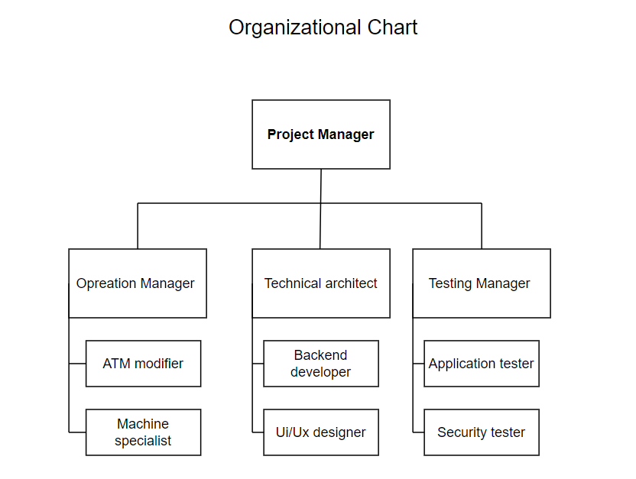

* Resources and funding:

|  |  |  |
| --- | --- | --- |
| Resources | Source | Funding |
| Executive Support | HR department | Wells Fargo |
| Project Team and Staff | HR department | Wells Fargo |
| Facilities | Techno Park | Wells Fargo |
| Equipment | HP | Wells Fargo |
| Software | Visual paradigm, Marvel, Figma, Docker etc.… | Wells Fargo |
| Materials | Al Haj Khaled and his sons | Wells Fargo |

* Signatures:

|  |  |  |
| --- | --- | --- |
| Position | Signature | Date |
| Responsible executive |  | 7/3/2022 |
| Project Manager |  | 3/7/2022 |
| Customer Representative |  | 3/7/2022 |

# Project Planning:

## : Project Schedule:

### : Work Break Structure:

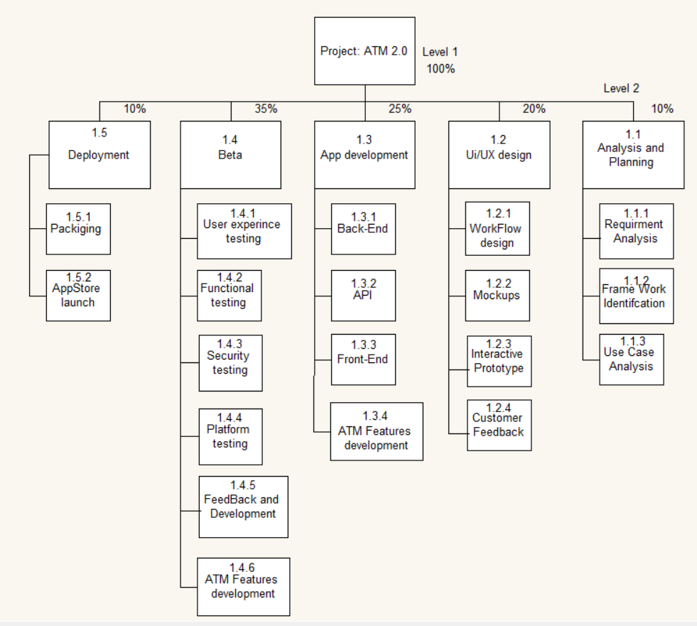

### : Gant’s Chart:

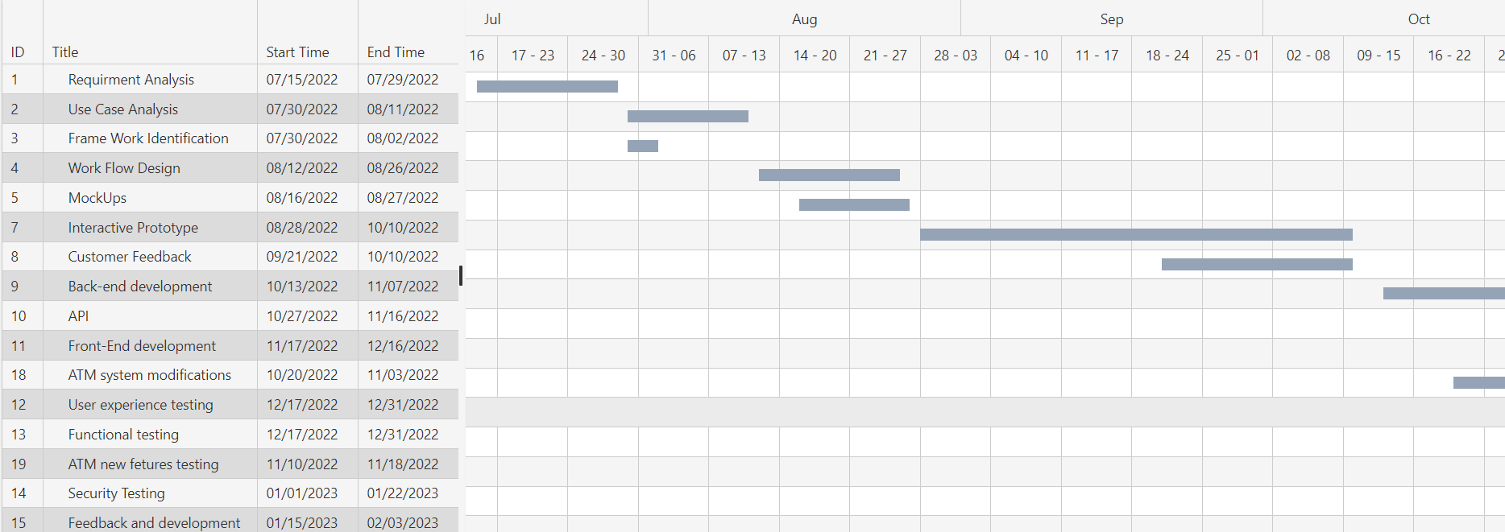

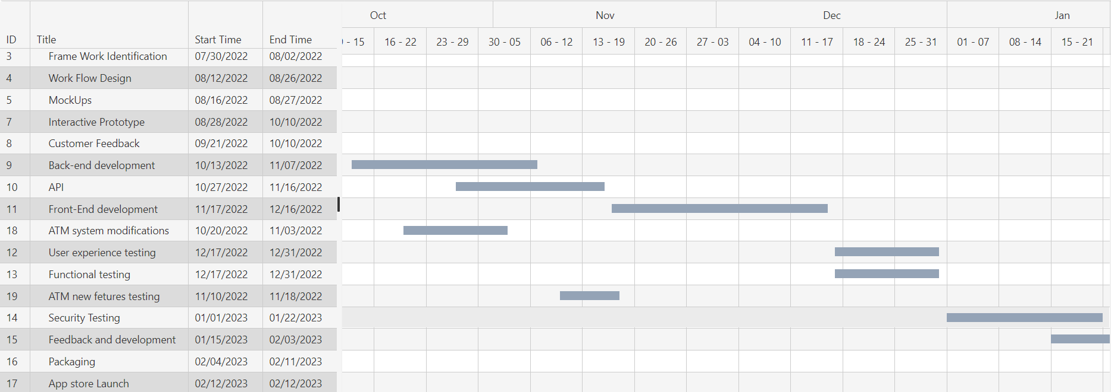

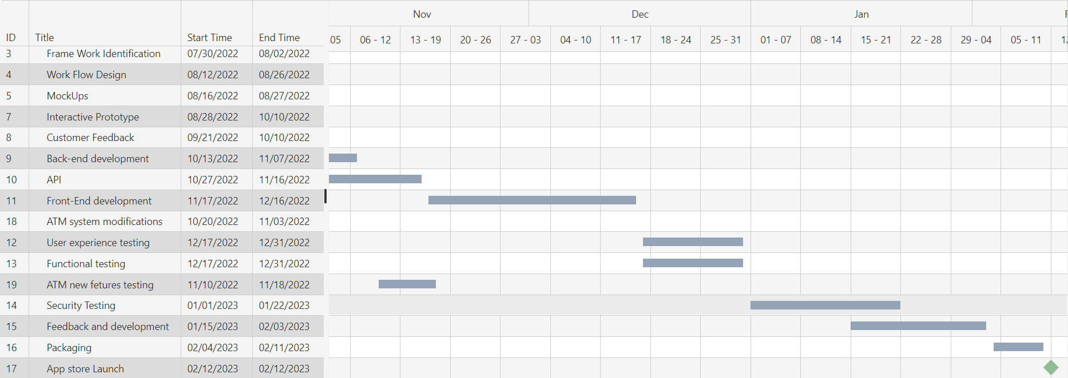

### : CPM NETWORK DIAGRAM:

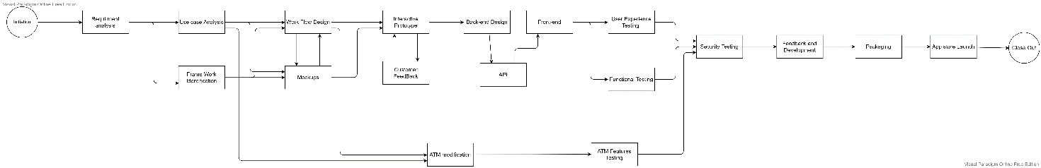

## Cost Estimation and Budget:

|  |  |  |  |  |  |  |  |  |  |  |  |  |  |
| --- | --- | --- | --- | --- | --- | --- | --- | --- | --- | --- | --- | --- | --- |
| Deliverable or Component | Quantity | | Material | | Equipment | | | | Work Hours | | | Cost | |
| System Requirements | - | | - | | Visual Paradigm | | | | 20 | | | 500$ | |
| Software Requirements | - | | - | | Visual Paradigm | | | | 15 | | | 450$ | |
| Hardware Requirements | - | | - | | Visual Paradigm | | | | 10 | | | 300$ | |
| Use cases | - | | - | | Visual Paradigm | | | | 30 | | | 600$ | |
| User flow diagram | - | | - | | Visual Paradigm | | | | 15 | | | 320$ | |
| Database servers | - | | - | | MySql | | | | 40 | | | 3000$ | |
| Design | - | | - | | Figma | | | | 50 | | | 4000$ | |
| UI SPEC (wireframes) | - | | - | | Marvel | | | | 20 | | | 750$ | |
| Programming | - | | - | | Sencha JS | | | | 60 | | | 5000$ | |
| Testing | - | | - | | Kobtain | | | | 70 | | | 8000$ | |
| Bug fixes | - | | - | | Jira | | | | 20 | | | 1000$ | |
| Enhancements | - | | - | | - | | | | 30 | | | 2000$ | |
| Installation | - | | - | | - | | | | 50 | | | 4500$ | |
|  | | Subtotals | | - | | 400 | | | 24920$ | | |
|  | Plus Indirect | | | | | 7500$ |
| Total | | 39420$ | | | |

## Human Resources Plan:

### Team Charter:

* Mission Statement:

Project access code ATM consists of the development, design, prototyping, testing of the Access code application for the ATM machine, The purpose of the project team is to complete the project on time, within budget, and according to specifications.

* Ground Rules:

The following ground rules are to be followed and guided as members of the team work together to accomplish the team’s mission:

Commitment: Members of the team are fully committed to complete the project on time, within budget, and according to specifications.

Punctuality: Members of the team are punctional about team meetings and all activities related to the project.

Honesty: Members of the team are honest and open with one another.

Dependability: Members of the team behave in ways that make them dependable.

Responsibility: Members of the team are responsible both as individuals and a group for completing the team mission.

No personal agendas: Members of the team priotrize the team needs above their personal agendas.

Patience: Members of the team are patient with each another when working together.

Decisions: Members of the team are to offer inputs before decision are made, in the decision-making process. Members of the team will fully support the decision that’s been made.

* Team Milestones:

1. Complete analysis and planning by august 11.

2. Complete user interface design by October 10.

3. Complete app development by December 16.

4. complete beta release by January 22.

5. complete Deployment by February 3.

## RACI Chart:

|  |  |  |  |  |  |  |  |  |  |
| --- | --- | --- | --- | --- | --- | --- | --- | --- | --- |
| RACI CHART  Access Code ATM project | | | | | | | | | |
| Activity | Team Members | | | | | | | | |
| Ibrahim | Osama | Mahmoud | Mousa | Walter | Logan | Jessie | Cersei | Jimmy |
| Design | I | C | A | C | I | I | I | I | I |
| Develop | R | C | R | A | I | I | I | I | I |
| Implement | I | A | R | R | I | I | I | I | I |
| Testing | I | C | C | C | A | C | I | I | I |
| Security | I | C | C | C | C | A | I | I | I |
| Modify ATM | I | I | C | I | C | C | A | R | R |

## Communication Plan:

Each one of the project’s stakeholders defined in the project charter have limited access to specific information inside the project, such as team information or process and product information as well, we have a daily or monthly update of the details for stockholders, and the information must be in a formal layout such as pdf or word documents, finally each stockholder has a limited authority on the information.

For our project :

* Project manager: have access on all of the information and data inside the project.
* Team Members: each team member have access to his personal information and area of work for example technical architect have access only to technical information.
* Other Stockholders : any other stockholder have access only to his area of work .

## Procurement Plan:

### Statements of Work:

Our project ATM with access code is a mobile application that aims to revolutionize remote banking experience. It requires these services with the following agreed upon details.

|  |  |  |  |  |  |
| --- | --- | --- | --- | --- | --- |
| Product/Service | Responsible member | Quantity/Months Required | Required Date. | Cost | Location |
| Visual Paradigm | Ibrahim Nobani | 2 | July/2022 | 45$/m | - |
| Marvel | Osama Rihami | 2 | August/2022 | 163$/m | - |
| Figma | Osama Rihami | 2 | September/2022 | 144$/m | - |
| Jira | Mahmoud Qaisi | 5 | August/2022 | 121$/m | - |
| Docker | Jessie lan | 5 | August/2022 | 222$/m | - |
| Postman | Mousa Owais | 2 | October/2022 | 229$/m | - |
| Jenkins | Jessie lan | 5 | August/2022 | 2$/s | - |
| Sencha Js | Mahmoud Qaisi | 2 | November/2022 | 500$ | - |
| Kobtain | Walter Pinkman | 3 | December/2022 | 2000$ | - |
| HP zbook Laptop | Ibrahim Nobani | 22 | July/2022 | 1765$/u | Birzeit-Techno Park |

### Request For Quote Document:

The following document was submitted to multiple companies for an order of laptops that will be used during this project.

Our Company Date: June 1st 2022.

Birzeit – Techno Park

(715) 234-1287, [SIbrahimN@barca.com](mailto:SIbrahimN@barca.com)

Subject: Request For Quote.

To: HP.

Address: HP headquarters - Ra'anana – Israel.

Dear Sir/Madame

We kindly request your quotation for the following items before July, 15th 2022 with the specified conditions, with the agreed upon prices below.

|  |  |  |  |
| --- | --- | --- | --- |
| Product | Quantity | Color | Size |
| HP ZBook Firefly 15 | 22 | Space Grey | 15.6 inches |

Conditions:

Each laptop must include and follow the following terms and conditions for this quote to be valid.

* Windows 11 Pro for business with a valid license.
* 15 G8 with Intel® Core™ i7-1185G7 vPro™ processor.
* OS Recovery feature.
* Intel® Iris® Xᵉ Graphics ( 1G3U9AV )
* Nvidia GeForce RTX 3080 Ti as a second graphics card.
* Product Price per unit must not exceed 1765$.
* The product must be able to work at maximum specs for at least 2 years.
* The product must be delivered prior to July 15th 2022.

## Risk analysis and Management:

* Risk Management Plan:

Risk and management process is an essential part of our project which help us find and deal with any potential risk that may arise during the execution of our project.

The risk identification methods we used:

* Brainstorming
* Literature review

After defining the risks, we classified them as shown in the Risk Breakdown Structure shown below:

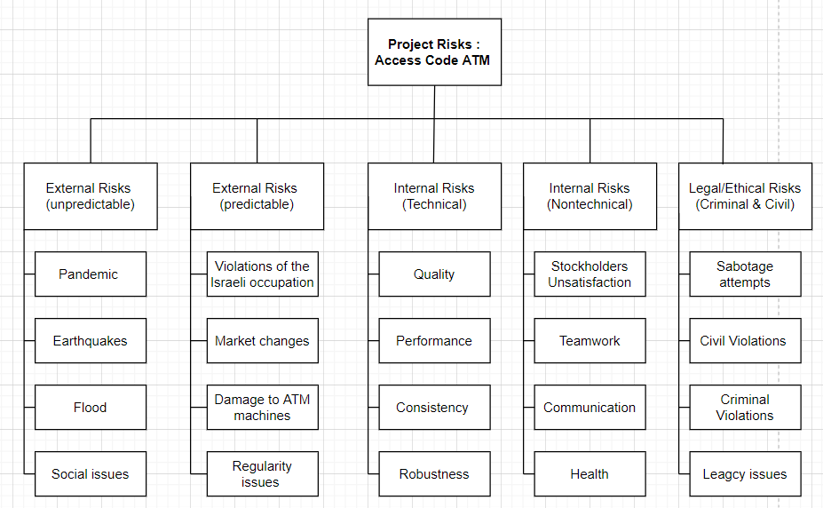

Then using Qualitative Risk Analysis, we build the Risk Matrix as shown:

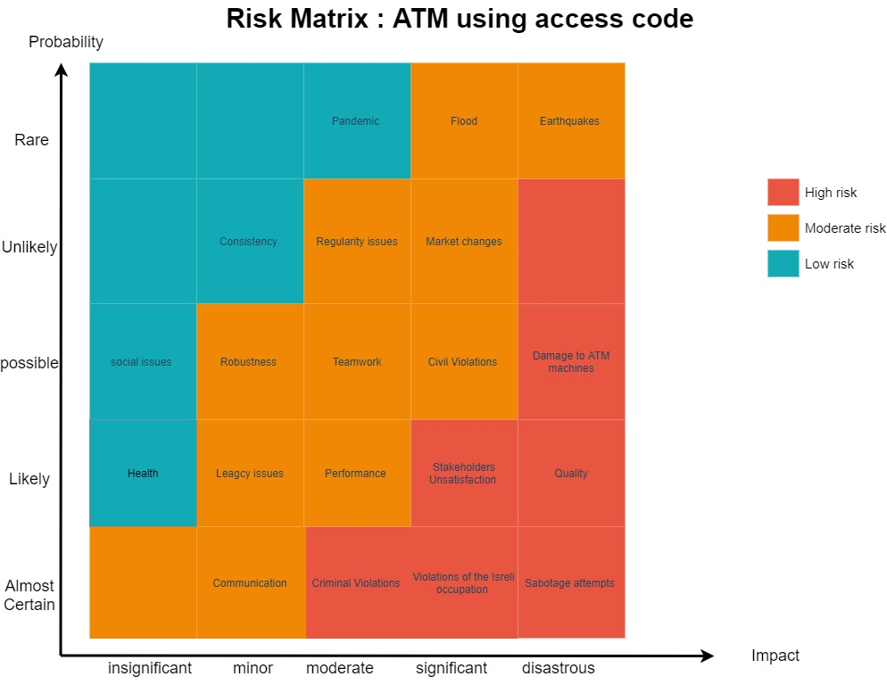

Many Risk strategies may be used to deal with risks such as Elimination, Transfer and Minimization.

The user wants to use the ATM to login to his account by using the app.

Normal: At first, the user chooses the login option on the app, then the system will ask for his password, the user will enter his password, after the login is done the system will give the user a 2-minutes code, then the user write the code to the atm and the PIN to login his account.

Error: (Robustness) app crash down from an internal error or due to many tries.

Solution: (Minimization) the app system should log out of the account and reboot in under 20 minutes, and if the system keeps crashing the account will be suspended and need the bank to reactivate it.

## Quality Management Plan:

### Quality Standards:

* The Application response time must not exceed a range of 1s to 20s to respond to different tasks done by users.
* The Application must be easy to use. The average user must be able to learn how to use it in a maximum amount of time that does not exceed 20mins.
* The application must have a smooth and logical transition functionality sequence that is easily understood by the user.
* The app must protect the user’s information and notify him whenever a threat might be affecting him.
* The cost of the application must not exceed the disclosed amount in the budget summary.
* Each task must be delivered by its decided deadline.

### Quality Measurements:

* The application will be tested by a group of selected users gathered for the purpose of this quality study. They will give their feedback. The results will be reported to the customer for his feedback and satisfaction with the results. They will also be compared to results with similar apps that have conducted the same studies.
* Feedback will be provided for the Ui/Ux designer and Technical Architect for necessary improvements if necessary.
* During the testing process the quality standards will be put to the test as well and results will be reported back as necessary.
* Jira will be used during this project to track down possible bugs the users may run into. The programmers in the development phase must keep track with the feedback form this tool to make any adjustments necessary.

### Quality Monitoring responsibility:

* The sole responsibility of the quality monitoring is for the Operational measurements. Employees must report the performance and cost after each stage for the operational manager to assess the progress the project manager. Changes can be made during the feedback duration in every stage.